Exercise 5: (在Blog用HTML來做表格)

Complete the table.

完成表格

因為找不到相關資料,所以直接比對答案

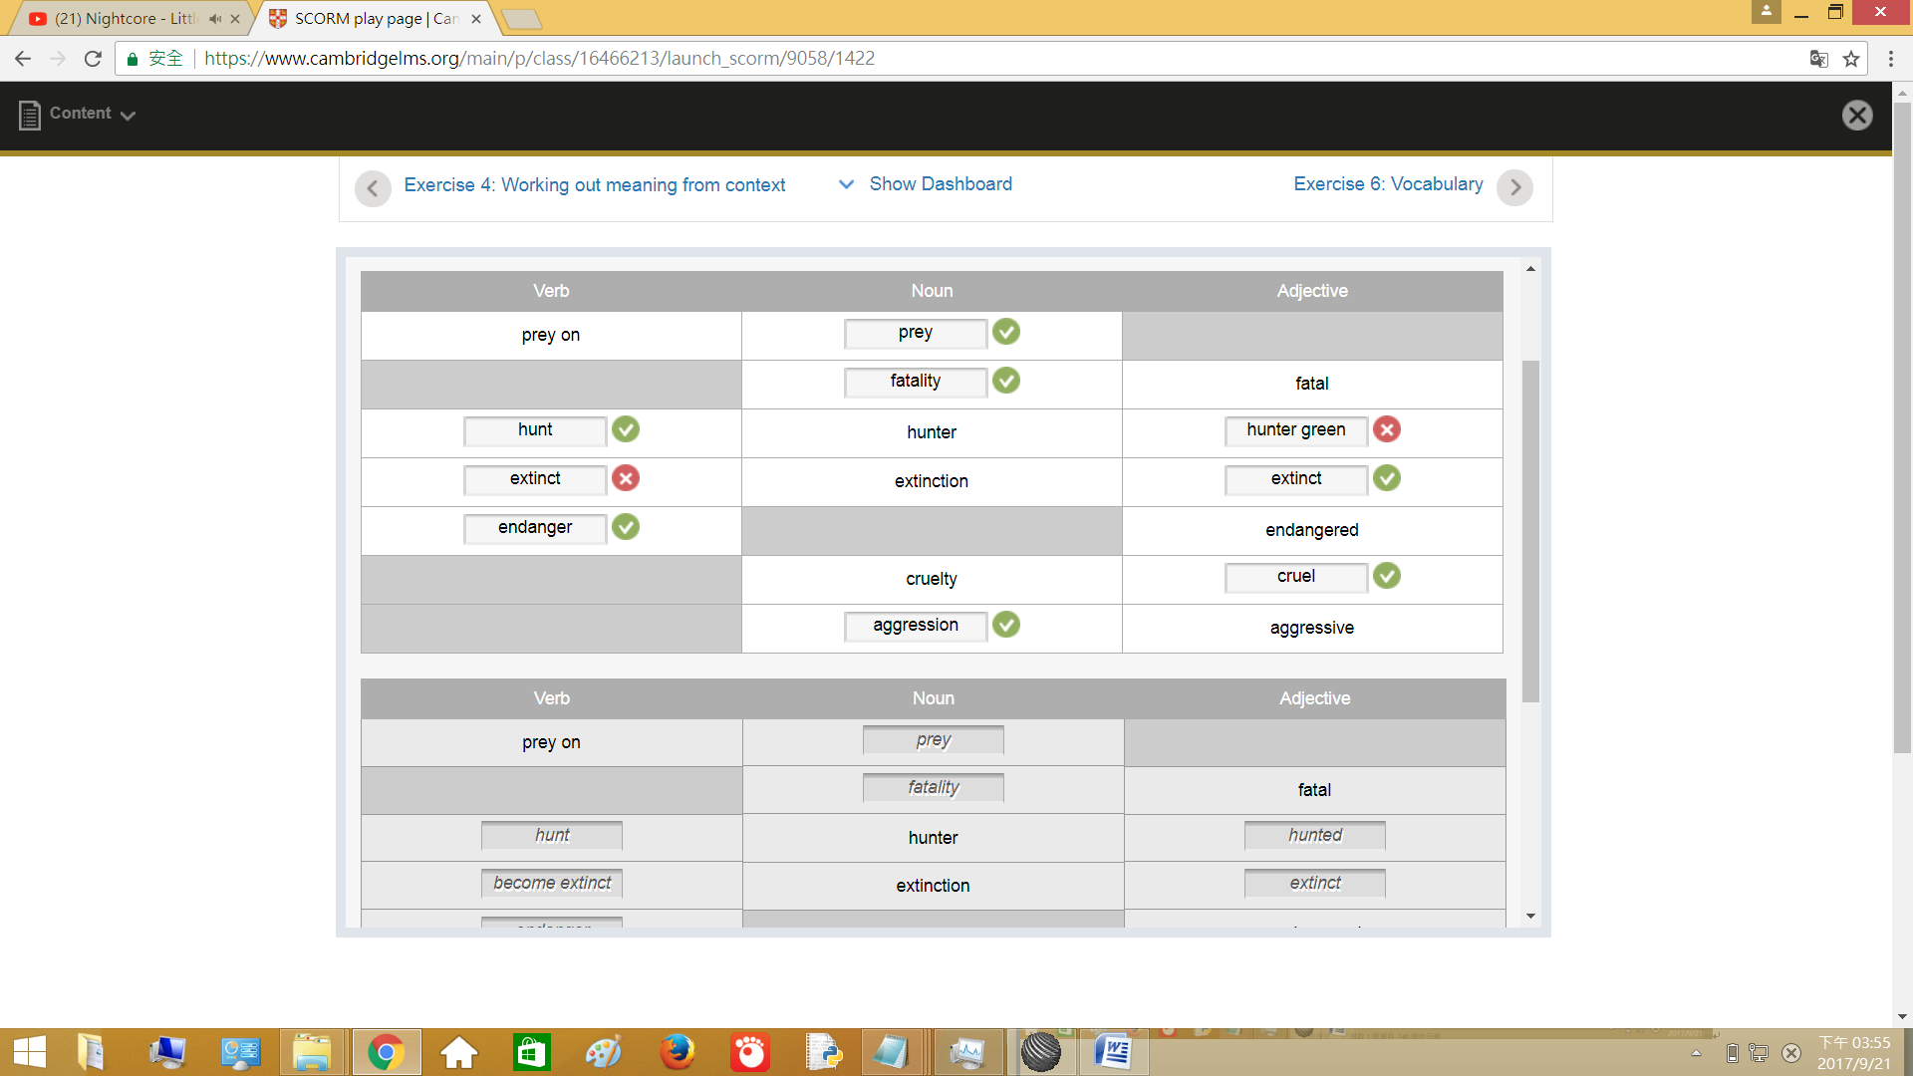

完成:

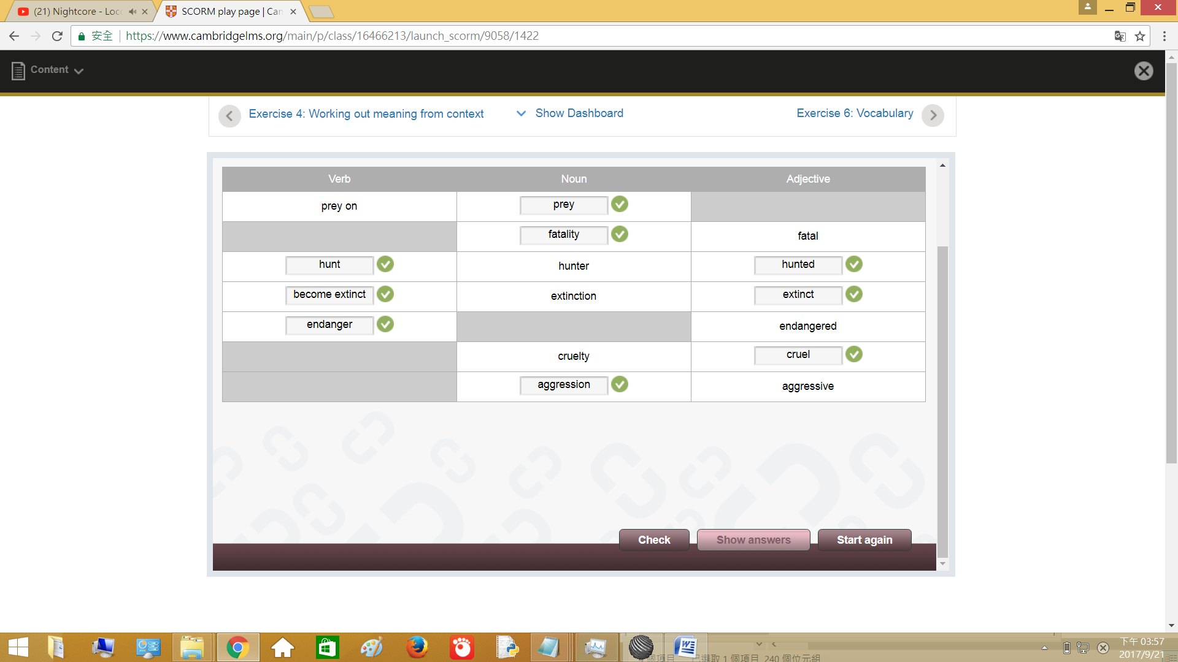

Exercise 6: [Vocabulary](https://www.cambridgelms.org/main/p/en/class/16466213/launch_scorm/8993/1422)

Complete the sentences using the correct forms of the words in brackets, and any other words you need.

使用括號中的單字完成正確句子,你需要其他字.

提示: 可參考Exercise 5

1. Some animals like the Arabian oryx have been hunted to the edge of [ 填寫 ] .(extinct)

一些動物像阿拉伯羚羊被 [ 填寫 ] 到邊緣. (面絕)

fill in: extinction

2. it is the way of nature that many wild animals [ 填寫 ] smaller animals for food. (prey)

許多野生動物 [ 填寫 ] 小動物為食物是自然法則. (狩獵)

fill in: prey on

3. If human behaviour does not change, many more animals will [ 填寫 ] .(extinct)

如果人類的行為不改變,非常多的動物將 [ 填寫 ] .(extinct)

fill in: become extinct

4. Animals can become more [ 填寫 ] if they believe they are in danger. (aggression)

動物可能有很強的 [ 填寫 ] ,如果他們在危險之中. (侵略性)

fill in: aggressive

5. In some countries, cruel to animals is a crime. (cruel)

在一些國家,對動物 [填寫] 是有罪. (殘忍)

fill in: cruelty

6. Both [ 填寫 ] and fishing are traditional ways of getting food. (hunt)

[填寫] 和釣魚是傳統得到食物的方法. (打獵)

fill in: hunting

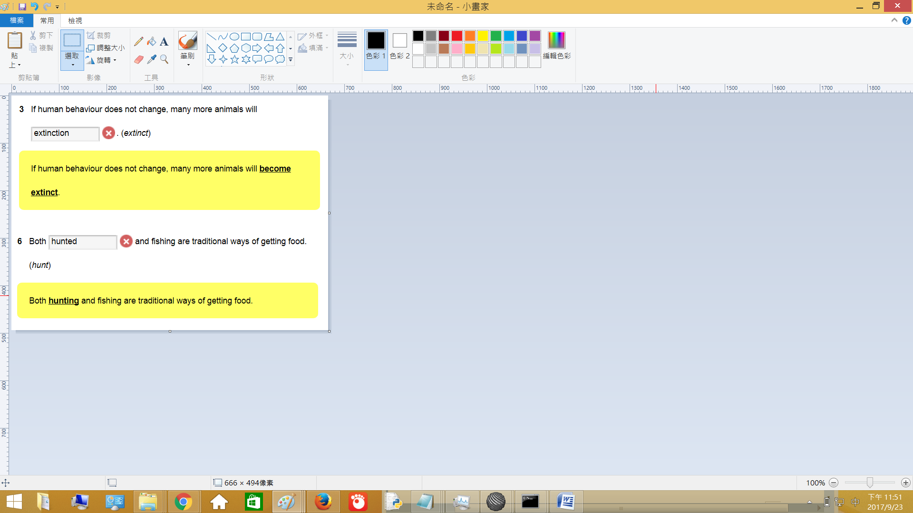

Exercise 7: Collocations (1)

Find the collocating words in the word search.

搜索並劃出列表中的單字

提示: 參考Exercise 8

1.work [ together ]

[ 一起 ] 工作

2.habitat [ destruction ]

棲息地 [ 破壞 ]

3.endangered [ species ]

瀕危 [ 物種 ]

4.against the [ law ]

違 [ 法 ]

5.financial [ penalty ]

金融 [ 罰款 ]

6.pay a [ fine ]

交 [ 罰金 ]

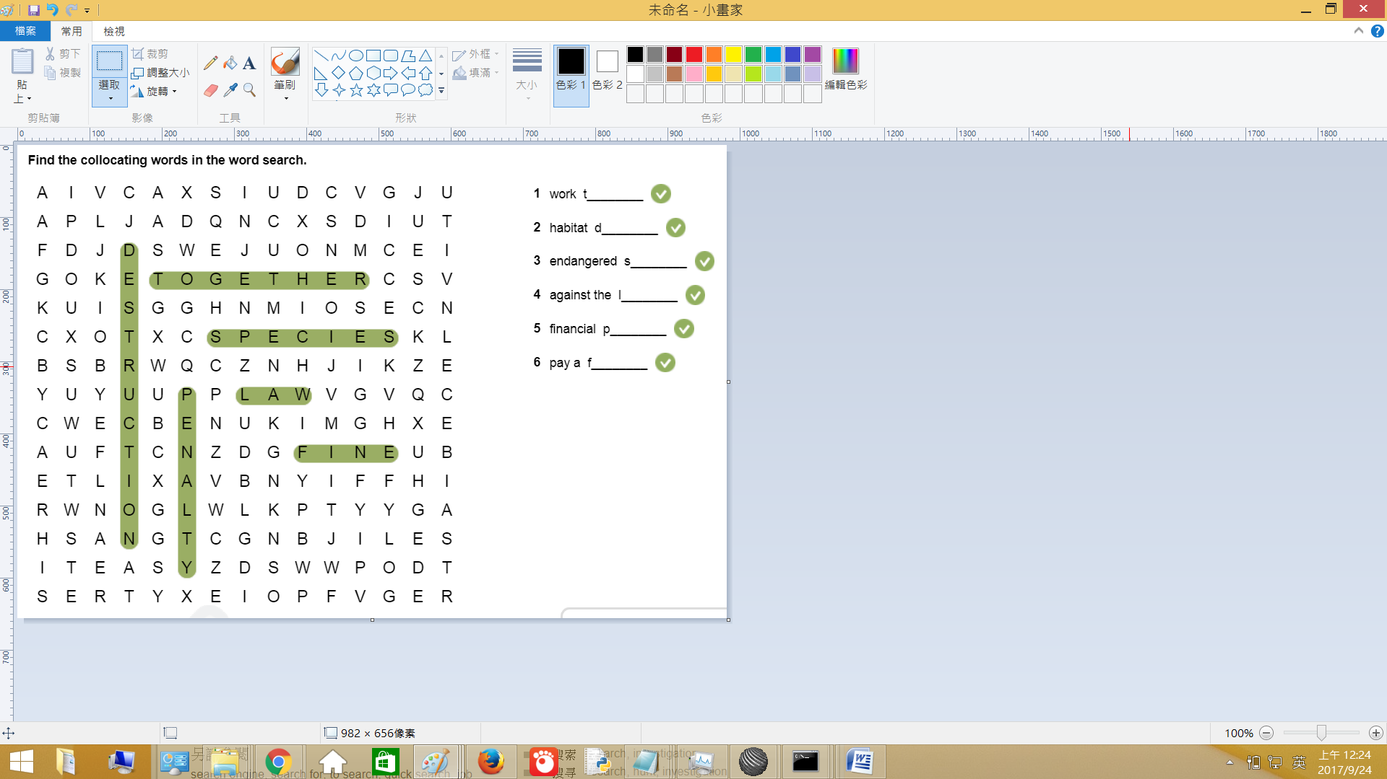

Exercise 8: Collocations (2)

Complete the sentences using collocations. Write no more than three words for each answer.

使用搭配完成句子.答案不能超出三個字.

financial penalties:金融罰款 pay a fine:交罰款 habitat destruction:破壞棲息地 against the law:違法 work together:一起工作 endangered species:瀕危物種

1. Governments, organizations and individuals must [ 填寫 ] to protect animals.

政府,組織和個人必須 [ 填寫 ] 保護動物

fill in: work together

2. Companies who destroy animal habitats should have to [ 填寫 ] .

公司破壞動物棲息地應該要 [ 填寫 ]

fill in: pay a fine

3. In some countries it is not yet [ 填寫 ] to hunt wild animals even if they are at risk of extinction.

在一些國家沒 [ 填寫 ] 獵捕野生動物即使(even if)有滅絕的風險.

fill in: against the law

4. One of the most beautiful of all the [ 填寫 ] is the snow leopard.

全部之中最美麗的 [ 填寫 ] 是雪豹.

fill in: endangered species

5. Deforestation is one of the main causes of [ 填寫 ] .

砍伐森林是 [ 填寫 ] 主要原因之一.

fill in: habitat destruction

6. Many people believe that there should be larger [ 填寫 ] for companies who damage the environment.

許多人的行為應該大量 [ 填寫 ] 公司傷害環境.

fill in: financial penalties

Exercise 9: Comparative adjectives

Complete the sentences using comparative forms.

使用比較完成句子.

1.Alligators are [ 填寫 ] crocodiles and do not usually attack humans. (aggressive)

鱷魚是有 [ 填寫 ] 鱷魚通常不會攻擊人類. (侵略性)

fill in: less aggressive than

2. The tiger shark is [ 填寫 ] the whale shark. (small)

虎鯊是 [ 填寫 ] 鯨鯊. (小)

fill in: smaller than

3. The Mongolian wild horse has [ 填寫 ] legs than the domestic horse. (short)

蒙古野馬有 [ 填寫 ] 腳比起國內的馬. (短)

fill in: shorter

4. The grey squirrel is [ 填寫 ] the red squirrel and can be seen a lot in parks. (common)

灰松鼠是 [ 填寫 ] 紅松鼠,在公園可以看到很多. (共同)

fill in: more common than

5. The whale shark is [ 填寫 ] the tiger shark and could become extinct. (endangered)

鯨鯊是 [ 填寫 ] 虎鯊可能滅絕. (瀕危)

fill in: more endangered than

6. The body of the Mongolian wild horse is [ 填寫 ] the body of the domestic horse. (big)

蒙古野馬的身體是 [ 填寫 ] 國內馬的身體. (大)

fill in: bigger than